[https://sqlbolt.com/](https://sqlbolt.com/" \t "_blank" \o "https://sqlbolt.com/)

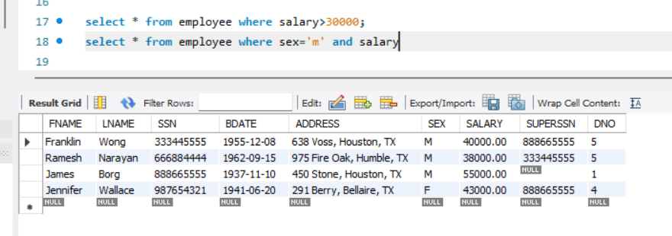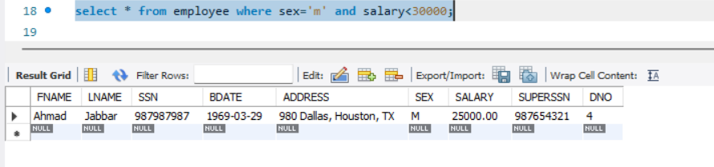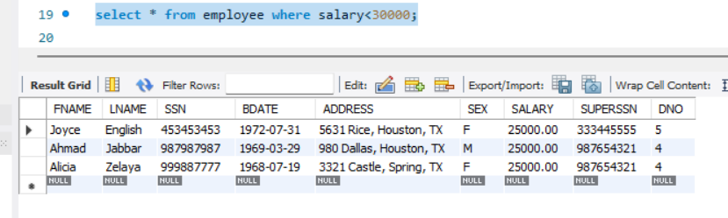

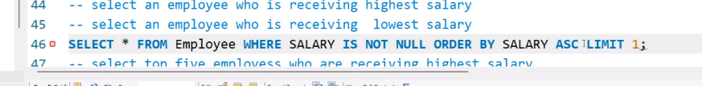

select salary from employee;

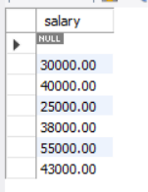

<https://stackoverflow.com/questions/409286/should-i-use-the-datetime-or-timestamp-data-type-in-mysql>

<https://sqlbolt.com/>

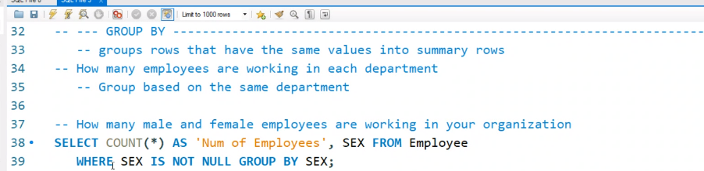



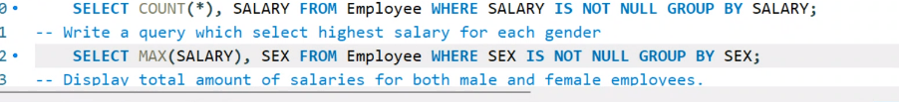

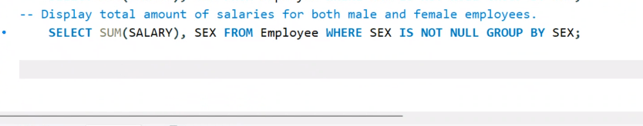

Initial Git Commands:  
git init  
git add .  
git commit -m "useful commit message"  
git branch -M main  
git remote add origin (URL of Git Repo)  
git push -u origin main

git remote set-url origin {your-new-url}

Should we install MongoDB and Mongosh over the weekend? YES

Investigate MySGL ‘JOIN’ command